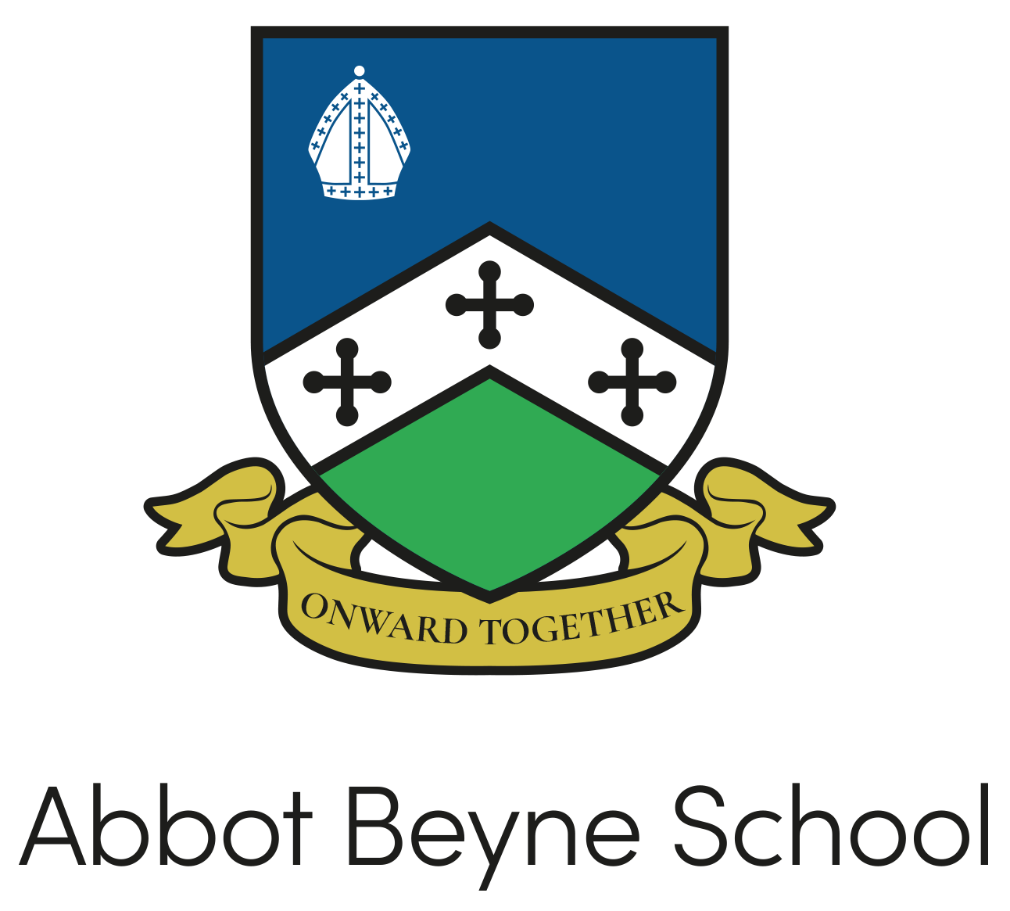

Policy: | CEIAG Policy  Careers Education, Information, Advice and Guidance
Person Responsible: | Laura Pollitt
Governors’ Committee: | Performance and Standards Committee
Date Adopted: | 2010
Revised Date: | Summer 2024 (Combination of 3 policies)
Next Review Date: | Summer 2026
Signature:

Policy for Careers Education, Information, Advice and Guidance
Rationale

All students have an entitlement to a structured programme of Careers Education, Information, Advice and Guidance (CEIAG) throughout their schooling so that they are inspired, informed and motivated to fulfil their potential. Good careers guidance widens students’ horizons, challenges stereotypes and raises aspirations. It provides students with the knowledge and skills necessary to make successful transitions to the next stage of their life. This supports social mobility by improving opportunities for all young people, especially those from disadvantaged backgrounds and those with special educational needs and disabilities.

Abbot Beyne School is committed to securing independent careers guidance for all Y8-13 students and to helping every student develop high aspirations and consider a broad and ambitious range of careers. Inspiring every student through more real-life contacts with the world of work can help them understand where different choices can take them in the future.

We aim to provide opportunities to a range of providers of technical education and apprenticeships to access students to inform them about technical education qualifications or apprenticeships. Our Provider Access Policy is displayed on the school website. This policy statement sets out the school’s arrangements for managing the access of providers to students at the school for the purpose of giving them information about the provider’s education or training offer. This complies with the school’s legal obligations under Section 42B of the Education Act 1997.

Context

Abbot Beyne School is an established school, our mission is to deliver an outstanding level of education whilst maintaining the students’ best interests at our core.

We want our students to recognise the importance of gaining skills and experiences as well as academic achievements, ensuring that they are offered these at various times in their learning journey with us is a key part of our careers programme. Our careers programme is delivered through form time, assemblies, personal development lessons and off timetable events. We are committed to offering students the opportunity to experience the work place through work experience in Year 10 and Year 12.

We are involved in East Staffordshire Careers hub, and with the support of our designated Enterprise Co-ordinator our careers strategy will enable us to achieve ‘good’ across all 8 Gatsby Benchmarks. As we increase our careers provision, we will work closely with our Careers Consultant and continue to use the Compass Careers Benchmark Tool to measure ourselves against the Gatsby Benchmarks. Our work is informed by current government guidelines and recommendations.

Key Personnel

SLT Careers Leader: Mrs L Pollitt, Assistant Headteacher
Careers Coordinator: Mrs L Wright
Link Governor: Mr J Trivedy

All queries regarding careers at Abbot Beyne School should be directed to Mrs L Pollitt, l.pollitt@abbotbeyneschool.co.uk

The aims of our CEIAG Programme:

Our vision is for all Abbot Beyne School students to have the best start in life and receive a good education so that they can make a positive contribution to their communities, enabling and promoting the effective participation in education or training. We recognise that all learning provision for young people requires bespoke programmes and includes support at transition points in order to avoid and reduce the dropout rate. In the Sixth Form, retention and achievement strategies are reviewed regularly to continually improve successful outcomes for all learners and to reach and exceed national averages.

Aims

Our careers programme aims are:

• Give all students appropriate guidance at specific transition points throughout their time at Abbot Beyne School ensuring that inputs are differentiated and personalised as appropriate to students’ stages of career learning, planning and development.
• Inspire students to think about their future possibilities; to aim high by motivating them in school and beyond; to be informed about education, training and career options; to assess their current strengths and areas for development; and to acquire the skills valued by employers
• Enable all students to develop the skills of self-reflection, independent learning and decision-making, alongside giving them the knowledge and understanding to be able to research careers and work-related issues effectively

With the use of the Gatsby Benchmarks we are regularly able to evaluate our careers provision against the ‘Careers guidance and access for education and training providers’ Dfe, 2023.

Implementation of our programme
 | Autumn Term | Spring Term | Summer Term
Key Stage 3 | Year 7: Onward Together encourages students to have aspirations towards future careers.  Year 8: problem solving workshop promotes employability skills.  Assembly with a training provider.  Year 9: Onward Together day is based around aspirations and careers.  Assembly with a training provider. | Year 7/8/9: In January all students are invited to the KS3 Careers Fair. With over 25 organisations attending they have a guided experience to engage with all the providers.  Year 7/8/9: National Careers Week events.  Year 8/9: Extended form time sessions and personal development lessons focus on careers.  Year 9: Pathways evening for GCSE options. | Year 7: Onward Together encourages students to have aspirations towards future careers.
Key Stage 4 | Year 10: extended form time sessions on personal development are focused on aspirations. Our  Careers Fair – October  Assembly with a training provider.  Year 11: extended form time sessions on personal development are focused on making choices.  Students have the opportunity to see our independent careers advisor.  Assemblies with apprenticeship providers and the Sixth Form team provide information on making next step choices.  Careers Fair – October  Mock interviews for all students  Assembly with a training provider. | Year 11: Students have the opportunity to see our independent careers advisor. | Year 10: In July students take part in the Year 10 Next Steps Day, the aim of this is to give students the opportunity to experience taster lessons of Level 3 subjects. This is supported by Burton & South Derbyshire College.  Extended form time sessions focus on careers.  Work experience for all Year 10 students.
Key Stage 5 | Year 12: guidance on applying for programmes to gain contextualised offers given through the form time programme.  Visits to higher education providers.  Careers Fair – October  Year 13: UCAS focus in form time, opportunities to visit higher education providers.  Careers Fair – October  Mock interviews for all students | Year 12: Extended form time focused on careers, pathways and choices available to students.  Visits to higher education providers.  Work experience for all students in Year 12  Year 13: All those not applying to UCAS have a careers advisor appointment to gain further guidance. | Year 12: UCAS discovery event, Post 18 Pathways Evening – supported by universities and apprenticeship providers. Assemblies with FE and HE providers. UCAS off timetable day supported by universities.  Form time programme focused on making informed choices.

